Helping Patients Feel Prepared to
Return to the Health Care Facility for Surgery
Surgeon Toolkit

Table of Contents:
- Introduction
- Template press release
- Template social media copy
- Template social media images
- Template video script
- Template article
- Additional considerations

INTRODUCTION

Since mid-March 2020, hospitals across the country and around the world paused most surgical care in order to preserve resources to treat critically ill COVID-19 patients. As hospitals now take steps to resume procedures following clearance from local and federal authorities, many patients continue to be apprehensive about returning to a health care facility – even to the extent that they are willing to delay or even cancel necessary surgical care.

In fact, new survey results show a third of patients are willing to wait at least three months after restrictions are lifted in their area to seek care, and one in five won’t be comfortable returning for procedures until six months have passed.* But as many surgeons know, patients fearful of risks may wait too long to seek the necessary, and sometimes even lifesaving, surgical care they need. Further, open communication may help alleviate some of the apprehension patients feel.

A new toolkit from the American College of Surgeons helps surgeons communicate with their patients about the steps their hospitals are taking to reduce the risk of COVID-19, and stresses that, when it comes to talking about COVID-19, surgeon-patient communication is a shared responsibility. The survey also found surgeons are the most influential voices for patients wondering whether their care will be safe. Personalized outreach, including phone calls, can ease fears and allow patients to ask questions about what they can expect when they arrive at the hospital, ambulatory center, or your office. They want to hear directly from you, and no level of detail is too much in our current environment. We’ve also developed a resource that patients can use to guide discussions. You can view the document here.

Included in this toolkit are templates and resources to help you reach out to patients directly who may also have wanted to reach out to you but are not comfortable making that first phone call. Also included are resources for traditional and social media, and your hospital or practice website, including:
- A communication guide, with sample questions that your patients may ask. This guide will help you gather the information you will need to have detailed conversations and answer potential patient questions.
- A template press release that you can distribute to your local media.
- Sample social media posts and tips for posting.
- A sample video script that can be used for recording on your phone or tablet, which you can post on social media or on your hospital or practice website. You can also work with your hospital’s media relations officer to record a video if your facility has its own studio or videographer.
- A draft newsletter article that you can post on your hospital or practice website.

Should you need assistance as you use these tools to navigate patient communications, you may reach out to the American College of Surgeons Integrated Communications team for assistance at covid19@facs.org.

We want to help you resume your practice, ensure your patients feel comfortable and receive timely care, and most important, ensure they avoid costly or even life-threatening delays in care. If we can provide more assistance, please do not hesitate to reach out. Additional COVID-19 tools and resources can also be found online at FACS.org/COVID-19.

* Revive Health. "Consumer Survey Update COVID-19." Accessed May 26, 2020. Available at: https://go.thinkrevivehealth.com/covid-findings-report-3.

PRESS RELEASE

This is a template press release to circulate to local media with the goal of securing interest in covering this topic to help spread awareness and education, as well as to communicate updates to the local community about your hospital or practice resuming elective procedures and care. Feel free to add other pertinent information that will make the press release relevant to your local media in terms of where your community is positioned in the COVID recovery phase process. Your hospital’s media relations team can be a great resource for you in completing this press release, too.

TIPS:
- There is a placeholder for a customized quote from you. The quote should help encourage the patients to contact you for a discussion on returning for surgery and alleviate anxiety and/or focus on the urgency behind patients returning, especially those needing essential surgical care.
- The final press release can also be posted to your hospital or practice website; also consider sharing a link on your social media channels.

HOW TO DISTRIBUTE:
- If you have a communications or marketing partner, please send this template to them for further action and distribution to local media.
- If you do not have a communication or marketing partner to assist, we still encourage you to leverage this press release. Once customized, send to local media contacts–-including broadcast stations and print/online reporters – via email, to gauge their interest in covering the topic and offering yourself for an interview or comment, if comfortable. The ACS Office of Public Information can assist you in identifying whom to contact. Email: pressinquiry@facs.org.
- The goal is to leverage local media as a platform to draw attention to this topic and help reach the target patient community to address their concerns.

PRESS RELEASE:

News from [INSERT HOSPITAL/PRACTICE]
For Immediate Release

MEDIA CONTACT:
Name
[000-000-0000]
Email: [XXX]
[INSERT HOSPITAL/PRACTICE] Resumes Operations and Prepares for Discussions with Patients about Safely Returning for Surgery

- [INSERT HOSPITAL/PRACTICE] is using new tools from the American College of Surgeons to prepare for return to operations in the time of COVID-19
- Includes discussion guide to help patients navigate the questions to ask to ensure a safe experience

[INSERT LOCAL CITY] (May XX, 2020): As health care facilities resume operations paused due to COVID-19 – including [INSERT HOSPTIAL/PRACTICE], a new survey shows a majority of consumers are fearful of undergoing procedures and may not reschedule necessary care while COVID-19 continues to circulate in communities. [INSERT HOSPTIAL/PRACTICE] wants patients to feel comfortable returning for needed care, and as part of that effort, it is using a new resource from the American College of Surgeons (ACS), “Preparing to have surgery during the time of COVID-19.”

The resource includes a patient-surgeon discussion guide with suggested questions patients can ask their surgeon to feel more prepared for returning to the health care facility. The guide also covers common concerns such as how the check-in process has changed, what to expect during appointments, safeguards to prevent the spread of COVID-19, and how the ongoing pandemic may change after-operation care.

New research found more than a third of patients would not feel comfortable returning to care until at least three months have passed after COVID-19 restrictions are lifted in their area, and one in five would not feel comfortable until over six months have passed.* Having frank and open discussions with their surgeons may help ease concerns about returning for care. Patients fearful of risks may wait too long to seek the necessary, and sometimes lifesaving, care they need.

[INSERT PERSONALIZED QUOTE - ATTRIBUTED TO YOU AS ACS MEMBER AND SURGEON/LEADER IN LOCAL HEALTHCARE COMMUNITY]

The new tools complement the hospital guidance document ACS released on April 17. [OPTION: INSERT 1-2 SENTENCES ON LOCAL HOSPITAL/PRACTICE REOPENING DETAILS]. [INSERT HOSPITAL/PRACTICE] is taking several important issues into consideration, including our [CUSTOMIZE AS APPLICABLE: community’s COVID numbers, personal protective equipment availability, adequate workforce, patient communication protocols, and the ability to deliver safe, high-quality care across the Five Phases of Care, which include preoperative, perioperative, intraoperative, postoperative, and post-discharge].

Preparing to have surgery during the time of COVID-19 is available here [facs.org/be-prepared].

###
______________

*Revive Health. "Consumer Survey Update COVID-19." Accessed May 26, 2020. Available at: https://go.thinkrevivehealth.com/covid-findings-report-3.

About the [INSERT HOSPITAL/PRIVATE PRACTICE]
[Placeholder for official boilerplate – if you do not have, insert a short paragraph about your hospital/practice]

About the American College of Surgeons
The American College of Surgeons is a scientific and educational organization of surgeons that was founded in 1913 to raise the standards of surgical practice and improve the quality of care for surgical patients. The College is dedicated to the ethical and competent practice of surgery. Its achievements have significantly influenced the course of scientific surgery in America and have established it as an important advocate for all surgical patients. The College has more than 82,000 members and is the largest organization of surgeons in the world. For more information, visit www.facs.org.

SOCIAL MEDIA COPY

The following sample posts can be used on your personal or professional social media channels to help promote and communicate the safe return to hospitals for elective surgery. Please adjust to fit your personal tone and style, as needed, and consider adding a more personal call to action directed at your patients. Images to use with the social media posts are also provided for adaptation, as well as instructions for how to easily adapt the images and share on social media.

TIPS:
- Using relevant hashtags, such as #COVID19 and #ACSCOVID19, will help expand the reach of your posts. Feel free to also tag the American College of Surgeons (@AmCollSurgeons) and we will support by liking or sharing across our channels, as appropriate.
- For all social channels, try to support posts with an engaging visual/image.
- Reminder that links in Instagram posts need to be inserted in your bio versus in the post copy (example below). An image or video will also be required for Instagram – examples include an image of your practice/hospital, your logo or a short personal video to accompany the message.

SAMPLE POSTS:

Twitter
- Example 1: Important surgical procedures still need to happen as we address #COVID19. Your surgeon’s #1 goal is reducing risk while helping you get the care you need. Patients, please check this out: @AmCollSurgeons #ACSCOVID19 facs.org/be-prepared
- Example 2: For many patients, necessary care can no longer be delayed. To help address your fears of returning to the hospital during #COVID19, talk to your surgeons. This resource from @AmCollSurgeons may help that discussion #ACSCOVID19 facs.org/be-prepared
- Example 3: Returning to the hospital for necessary care and feeling uneasy? @AmCollSurgeons created a new resource for patients to help you communicate with your surgeon and feel better prepared. facs.org/be-prepared

LinkedIn
- Example 1: Studies show patients are apprehensive about returning to hospitals, despite many needing necessary care. As hospitals and surgeons begin to resume procedures, it is imperative to communicate openly with patients to help them feel more comfortable and better understand the stringent safety measures in place at their hospitals. The American College of Surgeons created a new resource to help surgeons facilitate these discussions with patients. Check it out: facs.org/be-prepared
- Example 2: Open discussions between surgeons and patients will help ease fears around returning to the hospital for necessary, and often lifesaving, care. To help with these discussions, the American College of Surgeons has released a new resource, including a patient-surgeon discussion guide with suggested questions patients can ask their surgeon to feel more prepared for their procedure. It also covers common concerns such as check-in process, safeguards in place and more. facs.org/be-prepared

Facebook
- Example 1: As a surgeon, the well-being and safety of my patients is my #1 concern. While #COVID19 may be the new reality, please do not let it deter you from seeking necessary medical care. Hospitals have stringent procedures in place to reduce the chance of COVID-19 spreading. We want to make you feel as comfortable and address any questions you have. @AmCollSurgeons has created a new communication guide to help you, the patient, prepare for discussions with your surgeon and better prepared to return. Please check it out: facs.org/be-prepared #ACSCOVID19
- Example 2: Hospitals are starting to resume operations delayed by COVID-19. If you previously delayed a procedure due to #COVID19 or are putting off treatment for new symptoms, please read this new patient resource from @AmCollSurgeons. It provides questions to ask your surgeon or care team. facs.org/be-prepared #ACSCOVID19

Instagram
- Example 1: As a surgeon, the well-being and safety of my patients is my #1 concern. While #COVID19 may be the new reality, please do not let it deter you from seeking necessary medical care. We want to make you feel as comfortable and address any questions you have. @AmCollSurgeons has created a new communication guide to help you, the patient, prepare for discussions with your surgeon and better prepared to return. Link in bio.
- Example 2: Hospitals are starting to safely resume elective surgeries. If you previously delayed a procedure due to #COVID19 or are putting off treatment for new symptoms, please read this new patient resource from American College of Surgeons. It provides questions to ask your surgeon or doctor. Link in bio. #ACSCOVID19

SOCIAL MEDIA IMAGES

Social Media PowerPoint Templates

We suggest you print these instructions out for easy access. These templates can only be used on a personal computer.
These PPT templates have been created to allow you to customize your own social media quotes. There are two sizes, one for Facebook and one for Twitter.
There are three options: (1) ACS branded (2) Surgeon and patient talking (3) Checklist
Pick the one that works best for you.

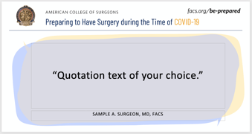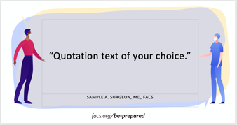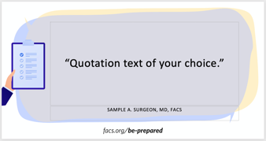

The templates include one editable text box for a quote and one text box for credentials. If no credentials are needed, simply delete this text box. Replace sample text with your own.

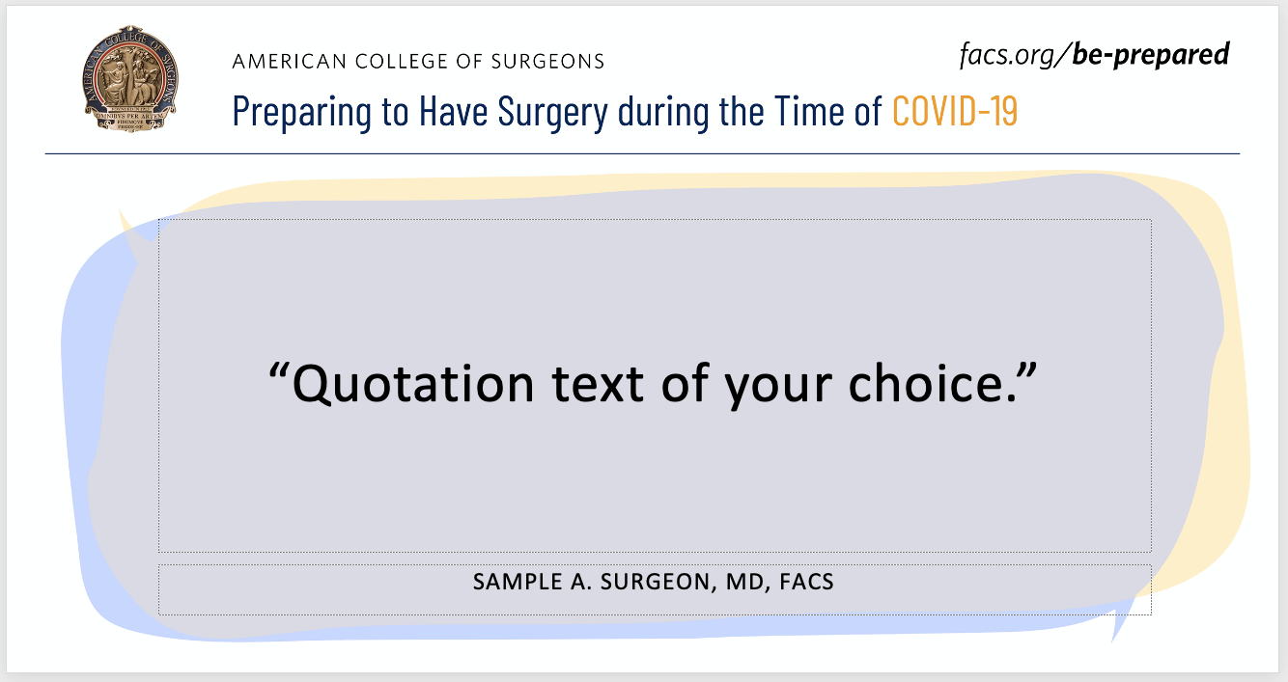

EXPORTING the final JPG:
- Click File > Export > Change File Type
- Select JPEG File Interchange Format (*.jpg) and double click on it
- Select the file location and file name
- Click Save
You can choose to export just the current slide or ALL the slides in your presentation.
Your branded quote is ready to share on Facebook or Twitter!

VIDEO SCRIPT

The following script can be used to film a short, informal video directed at patients. It is for use on your personal or professional social media channels, or to post on your practice website. The goal is to leverage your trusted voice to help instill confidence that it is safe and critical to return for necessary care and surgery.

TIPS:
- Optimal length for the video is 60 seconds or less. The script is to be used as a guide and may be adjusted to fit your personal tone and style.
- Be cognizant of your background and lighting, as well as your pace of speech.
- If interested in sharing on social media, we recommend posting the video with a short, succinct caption, such as – “An important message for returning to the hospital for non-COVID related care.”

SCRIPT:
- Hi, everyone. It’s [insert name], coming to you from [insert city and practice/hospital name].
- I have been hearing a lot of concerns from the community as hospitals start to resume essential operations.
- And I wanted to take a moment to reach out to provide some comfort and clarity during this uncertain time.
- I understand your concerns as a patient but want to assure you that we are prepared, and our number one goal – always – is to keep you safe.
- Hospitals, including [insert your hospital system/practice name], are taking extreme precautions as we resume essential surgical procedures.
- Please do not delay necessary care that is critical to your long-term health.
- I am here for you as a resource and want to answer any questions you may have. In addition, I have posted a link on [my website, Twitter, etc.] to a patient resource created by the American College of Surgeons that you can use when speaking with me or another physician about returning to the hospital for care.
- Stay safe, stay healthy. Thank you.

ARTICLE

This can be posted to your website to help address patients’ concerns about returning for procedures delayed by COVID.

TIP: If you proceed with publishing an article to your website, we recommend also sharing a link to it on your social media channels.

TEMPLATE ARTICLE:

Patients, are you apprehensive about returning for surgery
New tools available to guide patient-surgeon discussions and help address concerns

Research shows that patients are anxious about returning to hospitals, despite many needing essential or even life-saving procedures. According to new research findings, more than a third of patients would not feel comfortable returning to care until at least three months have passed after COVID-19 restrictions are lifted in their area, and one in five would not feel comfortable until over six months have passed.*

While this is a challenging and anxious time, hospitals that are restarting essential operations have prepared, and your surgeon and all those providing care, are ready to resume surgery. Patient safety is – and will always be – the top priority.
It is understandable that you – as a patient – may still have questions and specific concerns about the safety of undergoing an operation as COVID-19 continues to impact our community. To help you navigate through this time, the American College of Surgeons has released new tools to support frank conversations, including a patient-surgeon discussion guide with suggested questions you can ask your surgeon to feel more prepared for your procedure. The guide also covers common concerns, such as how the check-in process has changed, what to expect during appointments, safeguards to prevent the spread of COVID-19, and how the ongoing pandemic may change after-operation care.
Please know that we want to hear what is on your mind and answer your questions. Do not delay necessary care that is critical to your long-term health, and do not hesitate to reach out to schedule a discussion.
To learn more about the American College of Surgeon’s patient resources, visit facs.org/be-prepared.
Source: *Revive Health. "Consumer Survey Update COVID-19." Accessed May 26, 2020. Available at: https://go.thinkrevivehealth.com/covid-findings-report-3.

ADDITIONAL CONSIDERATIONS

The following are additional tactics to consider for helping ease patients’ minds as they return for necessary care in the current COVID-19 environment.

- Hospital or practice check in process – film short video(s) showing patients what they can expect as they enter the facility
- General summary of safety procedures – consider sharing an overview of what is different in the time of COVID-19, including a high-level summary of some of the measures that your hospital or practice is taking; this could be shared via an e-newsletter to patients and/or posted to your website and social media channels
- Patient success stories – ask patients to share their success from a recent operation on their personal social media channels, or request permission to feature a pull quote or short video testimonial on your website or social media channels
  - Note: Please keep in mind HIPPA laws and ensure you come to mutually agreeable terms with the patient in writing.

